Uganda Medical Mission

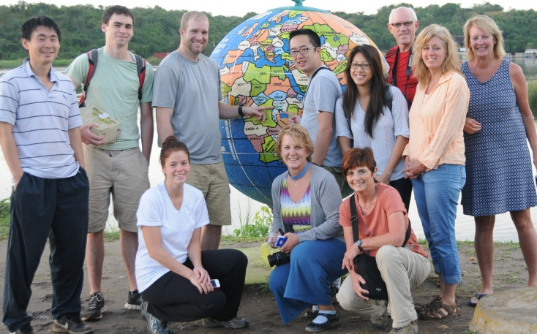
Why WE do this:
To demonstrate Christ’s love through meaningful and lasting service to those in greatest need.

Why Uganda:
- Level of need
- Lack of local medical facilities
- Depth of impact
- English speaking
- Stabilizing environment
- Local contacts – initially Jay Mundy and, more recently, local government leaders
- Foundation already created

By the numbers
- >2000 patients provided vitamins and medication
- 500 people fitted with eye glasses
- 1000 homes provided with mosquito nets
- 1000 people tested for HIV
- 54/57 male/female life expectancy in Uganda
- 1 in 10 people have malaria
- 1 in 20 people are HIV positive
- 1 medical resident in Luuka serving 185,500 people
- 1 medical facility serving the 250 square miles of Luuka

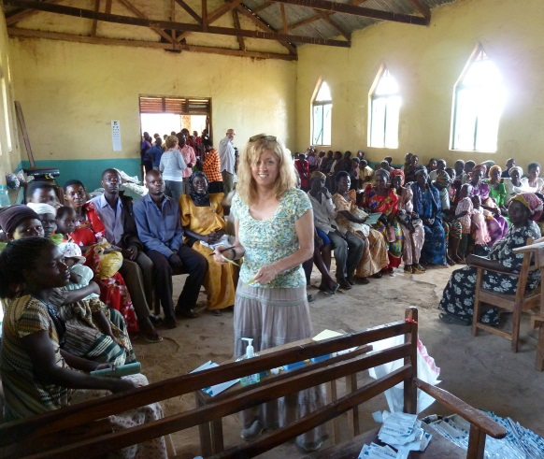
Benefits to people served:
- Hope through witnessing the generosity of Christ’s servants
- Immediate relief for acute medical issues
- Reduced incidents of Malaria
- Improved HIV awareness and education
- Improved nutrition through vitamin supplements
- Skills to start new careers
- Foundation for improved year round local medical care

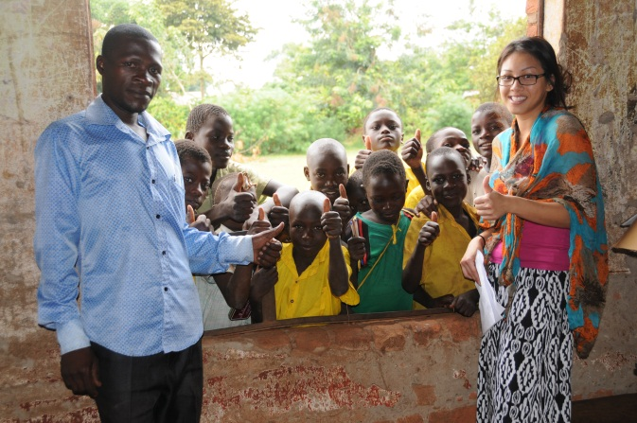
Benefits for those serving:
- Rewards of serving a great need
- Appreciation for life at home
- Witnessing the appreciation from those served
- Experience of working in a 3rd world medical clinic
- An understanding of the hardships of life in rural Africa
- Learning another culture

Benefits for supporters:
- Opportunity for all members to support through prayer, donations, and
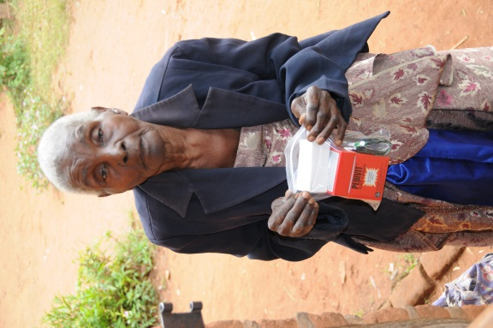
service
- Inspires us to think bigger and beyond
- Increases gratitude for all that we have
- Provides perspective
- Educates
- Expands global/cultural understanding for all ages
- Opportunity to connect to others in the community (local, regional,
national)
- Shows WE have a heart for service worldwide

