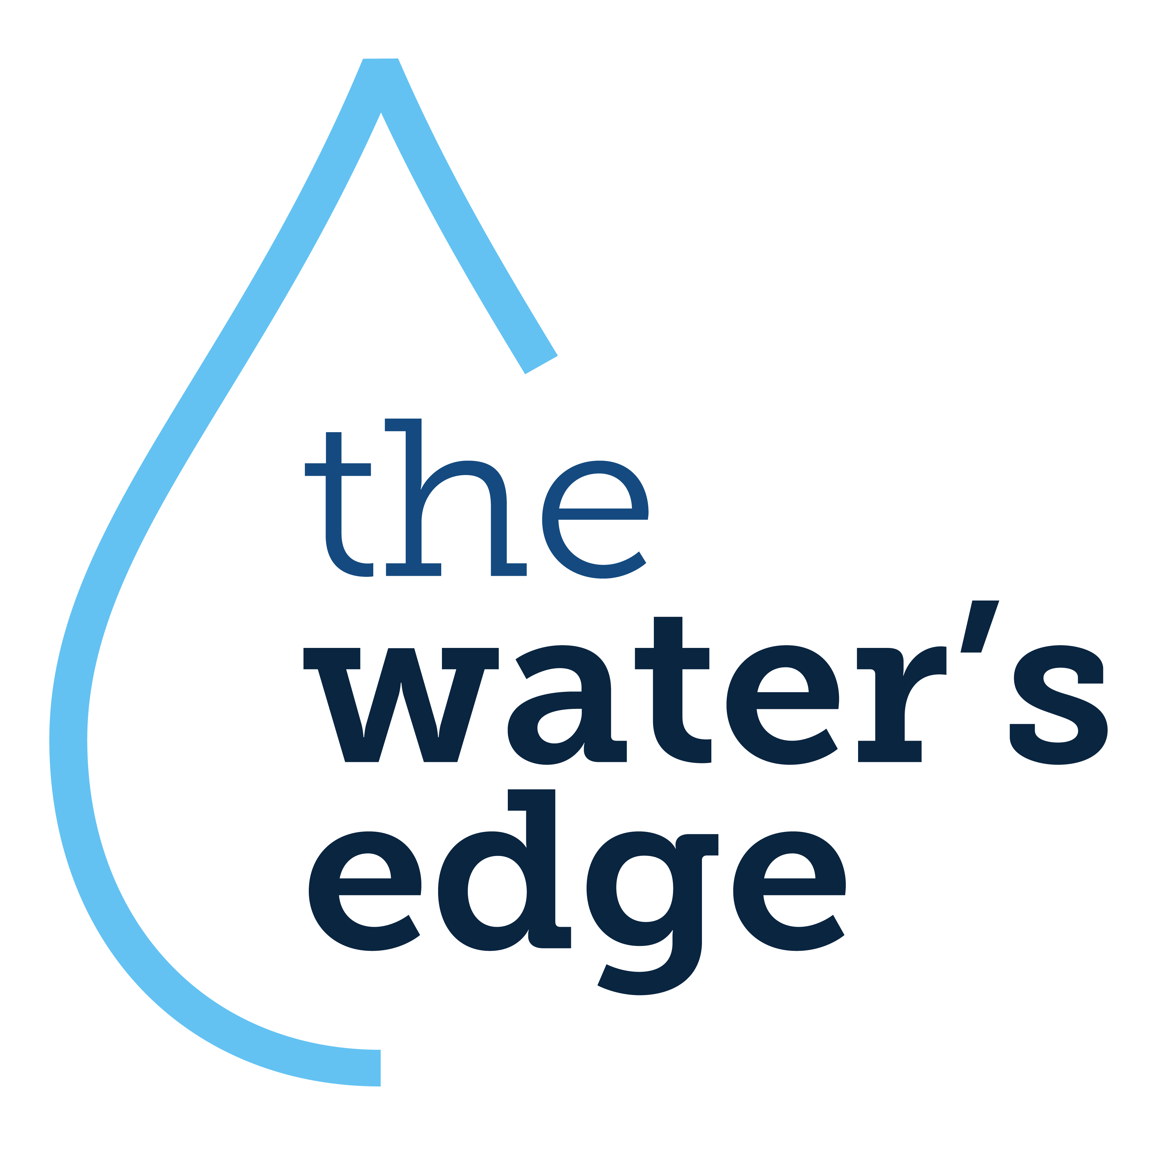
2024 Belize
Summer Mission Trip

Trip Dates: June 8-16, 2024
Age: Adult
Type of Trip: Medical, Community Support
Trip Capacity: 20 people
Estimated Cost: $2,000-2,200*

Description:
Serving remote villages in the country of Belize. Day-long clinics are held, providing medical & eye exams, medicine, and eyeglasses. This typically is the only healthcare received by these villagers in a years’ period.

Typical Day:
7:00 AM – Breakfast and gather supplies for the day
8:00 AM – Morning devotions
8:30 AM – Depart for village
5:30 PM – Arrive at host site for dinner
6:30 PM – Return to lodging site for clean-up and free time
Nature of Clinics:
Each person seeking healthcare is taken through an initial assessment, including documentation of the reason for their visit, demographics, blood pressure, weight, etc. They will then be examined by a doctor, where it is determined if our team can assist them with their health concerns. A prescription may be ordered, which would then be filled by our pharmaceutical volunteers. If they are seeking an eye exam and eyewear, they will meet with someone to assess those needs as well. Upwards of 175 people are seen each day.

Team Structure:
At least one doctor and one pharmacist are part of the team. A registered nurse/phlebotomist is needed for any blood draws. For the remainder of the team, no medical experience is required. These individuals will be trained to conduct eye exams, and to assist the doctors, nurses, and pharmacists in patient evaluation and dispensing medicine. There is also opportunity to interact with the community – particularly the children. Various activities are planned for each village.

Medical Consideration:
Volunteers must be in good health and able to work in a hot, humid climate. All meals are prepared using local foods, therefore we are not able to accommodate food allergies or special dietary needs.

Other Activities:
In addition to travel days and clinic days, there are a few days built into the trip to enjoy the Belizean culture. Past activities have included cave tubing, snorkeling, visiting Mayan ruins, and shopping for souvenirs.

*$200 deposit due 2/1/24 along with registration/application. The remainder is due 30 days before trip departure.

